

**18CS2053 – Web Technology Lab**

**[URK20CS2039]**

|  |  |
| --- | --- |
| **Ex. No. 7** | **JQuery** |
| **Date of Exercise** | **12/10/2022** |
| **Web Host Link** | https://github.com/Jeevansiddhartha/web-tech |
| **Youtube Link** | https://youtu.be/xeEon5uX5do |

**Aim :** To create web pages using various JQuery Effects, Elements and traversingin Jquery

# Description :

**Add Element :**

* append() - Inserts content at the end of the selected elements
* prepend() - Inserts content at the beginning of the selected elements
* after() - Inserts content after the selected elements
* before() - Inserts content before the selected elements

# Remove Elements

* remove() - Removes the selected element (and its child elements)
* empty() - Removes the child elements from the selected element

# Traversing

* he <div> element is the **parent** of <ul>, and an **ancestor** of everything inside of it
* The <ul> element is the **parent** of both <li> elements, and a **child** of <div>
* The left <li> element is the **parent** of <span>, **child** of <ul> and a **descendant** of <div>
* The <span> element is a **child** of the left <li> and a **descendant** of <ul> and <div>
* The two <li> elements are **siblings** (they share the same parent)
* The right <li> element is the **parent** of <b>, **child** of <ul> and a **descendant** of <div>
* The <b> element is a **child** of the right <li> and a **descendant** of <ul> and <div>



Ex. 7 | JQUERY

1



**18CS2053 – Web Technology Lab**

**[URK20CS2039]**

# JQuery Effects:

|  |  |
| --- | --- |
| **Method** | **Description** |
| animate() | Runs a custom animation on the selected elements |
| clearQueue() | Removes all remaining queued functions from the selected  elements |
| delay() | Sets a delay for all queued functions on the selected elements |
| dequeue() | Removes the next function from the queue, and then executes the function |
| fadeIn() | Fades in the selected elements |
| fadeOut() | Fades out the selected elements |
| fadeTo() | Fades in/out the selected elements to a given opacity |
| fadeToggle() | Toggles between the fadeIn() and fadeOut() methods |
| finish() | Stops, removes and completes all queued animations for the selected elements |
| hide() | Hides the selected elements |
| queue() | Shows the queued functions on the selected elements |
| show() | Shows the selected elements |
| slideDown() | Slides-down (shows) the selected elements |
| slideToggle() | Toggles between the slideUp() and slideDown() methods |
| slideUp() | Slides-up (hides) the selected elements |
| stop() | Stops the currently running animation for the selected elements |
| toggle() | Toggles between the hide() and show() methods |



Ex. 7 | JQUERY

2



**18CS2053 – Web Technology Lab**

**[URK20CS2039]**

**Question 1 :**

Car moving animation using Jquery

**Program :**

<!DOCTYPE html>

<html>

<head>

<title>Moving Car</title>

<meta charset="UTF-8">

<meta http-equiv="X-UA-Compatible" content="IE=edge">

<meta name="viewport" content="width=device-width, initial-scale=1.0">

<title>Document</title>

<script src="https://ajax.googleapis.com/ajax/libs/jquery/3.6.0/jquery.min.js"></script>

<script>

$(document).ready(function(){

$(document).keydown(function(event){ var car = $('#car')

var arrow = {left: 37, up: 38, right: 39, down: 40 }; switch(event.which){

case arrow.right: car.css('transform','rotate(360deg)'); car.animate({left:'+=5px'},1);

break;

case arrow.down: car.css('transform','rotate(90deg)'); car.animate({top:'+=5px'},1);

break;



Ex. 7 | JQUERY

3



**18CS2053 – Web Technology Lab**

**[URK20CS2039]**

## case arrow.up: car.css('transform','rotate(270deg)'); car.animate({top:'-=5px'},1);

break;

## case arrow.left: car.css('transform','rotateY(180deg)'); car.animate({left:'-=5px'},1); break;

}

## var car = $('#car');

var car_pos = $('#car').position(); var l = car_pos.left; var t = car_pos.top;

## if (l > 0 && l < 268 ) { if(t < 85 || t >250)

{

## $('#car').fadeOut('slow');

$('#car').fadeIn('slow');

## }

}

## if (l >470) {

if(t < 85 || t >250)

## {

$('#car').fadeOut('slow');

## $('#car').fadeIn('slow');

}

## }

})

## })

</script>



Ex. 7 | JQUERY

4



**18CS2053 – Web Technology Lab**

**[URK20CS2039]**

## <style>

*{

## margin: 0px; padding: 0px; box-sizing: border-box;

}

## .r1 {

position: fixed; z-index: 0; top:0px; width: 200px; height: 800px; left: 40%;

## background-color: black;

}

## .r2{

position: fixed; top:100px;

## z-index: 1;

width: 100%; height: 200px;

## background-color: black;

}

## </style>

</head>

<body>



Ex. 7 | JQUERY

5



**18CS2053 – Web Technology Lab**

**[URK20CS2039]**

<div id="car" style="position:absolute;z-index:3;left:5px; top:100px;width:80px;height:50px;">

<img id="car" src="Q1.jpg" alt="" width="80" height="50">

</div>

<br>

<div class="r1"></div>

<div class="r2"></div>

</body>

</html>

# Output :

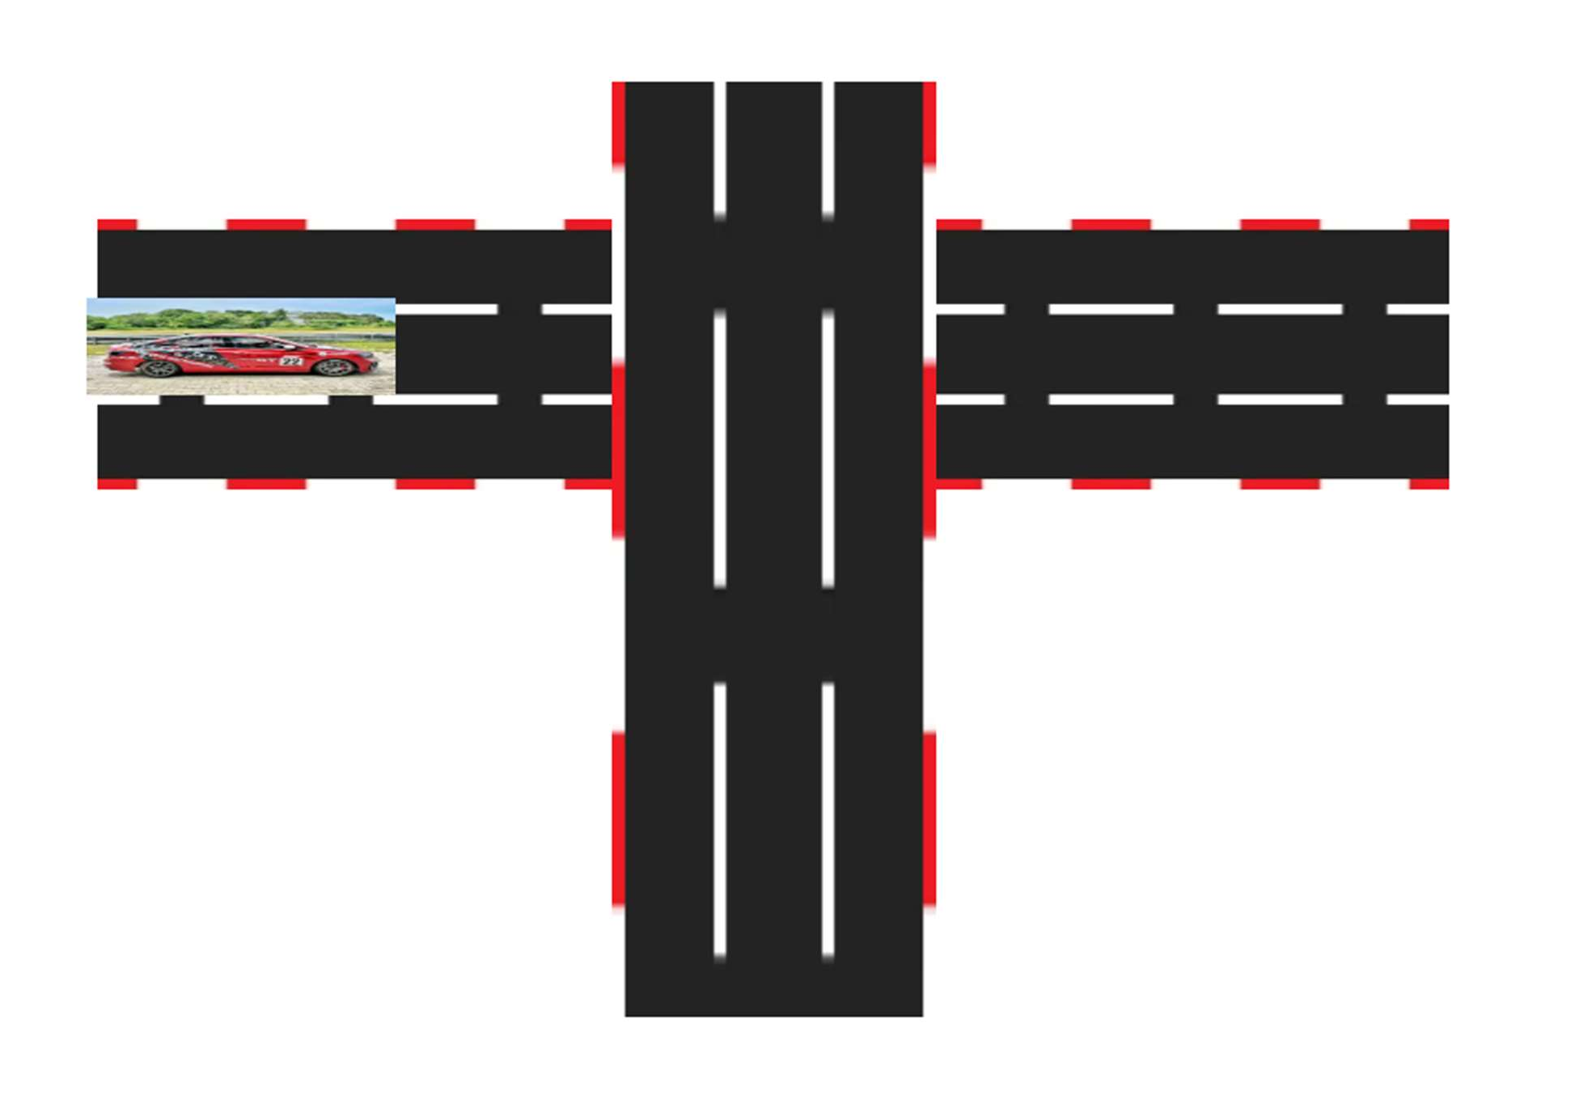



Ex. 7 | JQUERY

6



**18CS2053 – Web Technology Lab**

**URK20CS2039**

**Question 2 :**

Create a dynamic Registration form and display it in the same page using JQuery

1. Use Dom_get and dom_set to the set the values to the form
2. Dynamically add buttons and remove buttons
3. Use traversing function to display dynamically generated value in the result display portion

# Program :

<!DOCTYPE html>

<html>

<head>

<title>Registration Form</title>

<h1>Registration Form</h1>

<script src="https://ajax.googleapis.com/ajax/libs/jquery/3.6.0/jquery.min.js"></script>

<style>

.ancestors * { display: block; border: 2px solid rgb(0, 0, 0);

color: rgb(40, 29, 29); padding: 5px; margin: 15px;

}

</style>

<script>

$(document).ready(function(){

$("#add").click(function(){

$('#out').append("Name : " + $('#name').val() + "<br>Reg.No : " + $('#Reg').val() + "<br>");

});

$("#remove").click(function(){

$("#div").remove()

});

});

</script>

</head>



Ex. 7 | JQUERY

7



**18CS2053 – Web Technology Lab**

**[URK20CS2039]**

<body>

Name : &nbsp; &nbsp; <input type="text" id="name"><br><br> Reg.No. : <input type="text" id="Reg"><br><br>

<div class="ancestors" id="div">

<p id="out"> </p>

</div>

<button id="add">Append text</button>

<button id="remove">Remove text</button>

</body>

</html>

**Output :**

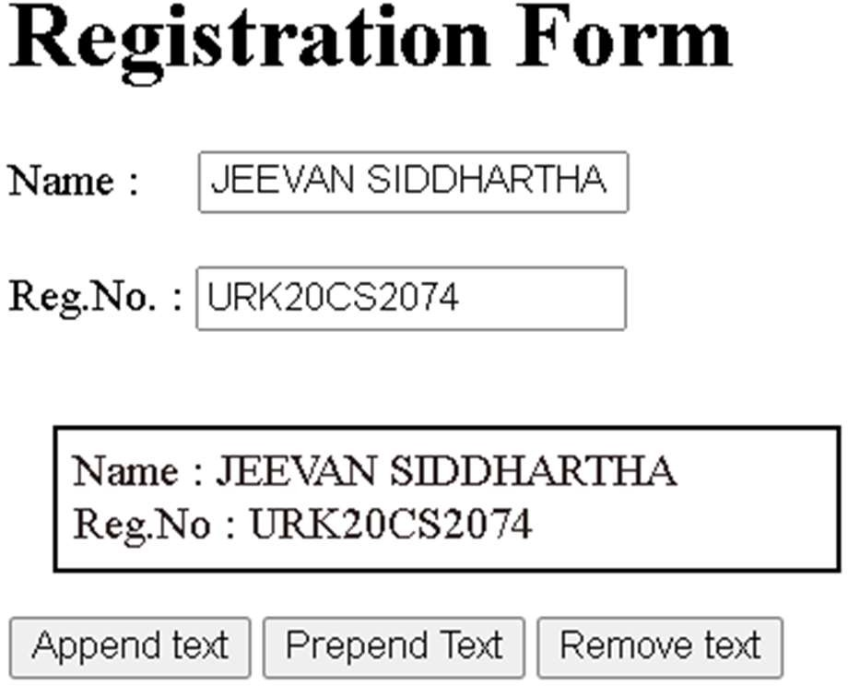

# Question 3 :

Create a car body workshop using JQuery where in you should be able to change the color of thecar, glass tint, size of the tyres.

# Program :

<!DOCTYPE html>

<html>

<head>

<script src="https://ajax.googleapis.com/ajax/libs/jquery/3.6.0/jquery.min.js"></script>



Ex. 7 | JQUERY

8



**18CS2053 – Web Technology Lab**

**[URK20CS2039]**

<meta name="viewport" content="width=device-width, initial-scale=1">

<style>

.trapezoid{

border-bottom: 50px solid #555; border-left: 25px solid transparent; border-right: 25px solid transparent; height: 0;

width: 125px;

}

.circle{

height: 50px; width: 50px; background-color:rgb(0, 0, 0);

border-radius: 50%; display: inline-block;

}

.rectangle{

height: 50px; width: 250px; background-color: gold;

}

</style>

<script>

$(document).ready(function(){

$("#body_col").click(function(){

var red = Math.floor(Math.random()*255); var blue = Math.floor(Math.random()*255); var green = Math.floor(Math.random()*255); var color =

"rgb("+red+","+green+","+blue+","+cornblue+","+purple+","+black+")";

$("#body").css({"background-color": color, });

});

$("#tyre_size_increase").click(function(){ size = "75%"

h = "75px" w = "75px"

$("#tyre1").css({"border-radius": size, "height": h, "width": w, })

$("#tyre2").css({"border-radius": size, "height": h, "width": w, });;

});

$("#tyre_size_decrease").click(function(){ size = "50%"

h = "50px" w = "50px"

$("#tyre1").css({"border-radius": size, "height": h, "width":



Ex. 7 | JQUERY

9



**18CS2053 – Web Technology Lab**

**[URK20CS2039]**

w, })

$("#tyre2").css({"border-radius": size, "height": h, "width": w, });;

});

});

</script>

</head>

<body><h1>Trapezoid CSS</h1>

<div class="trapezoid"></div>

<div class="rectangle" id="body"></div>

<div class="circle" id="tyre1"></div> &nbsp;&nbsp;&nbsp;&nbsp;&nbsp;&nbsp;&nbsp;

&nbsp;&nbsp;&nbsp;&nbsp;&nbsp;&nbsp;&nbsp;&nbsp;&nbsp;&nbsp; &nbsp;&nbsp;&nbsp;&nbsp;&nbsp;&nbsp;&nbsp;&nbsp;&nbsp;&nbsp;&nbsp

;&nbsp;

<div class="circle"id="tyre2"></div><br>

<button id="body_col">Body Colour</button>

<button id="tyre_size_increase">tyre size increase</button>

<button id="tyre_size_decrease">tyre size decrease</button>

</body>

</html>



Ex. 7 | JQUERY

10



**18CS2053 – Web Technology Lab**

**[URK20CS2039]**

# Output :

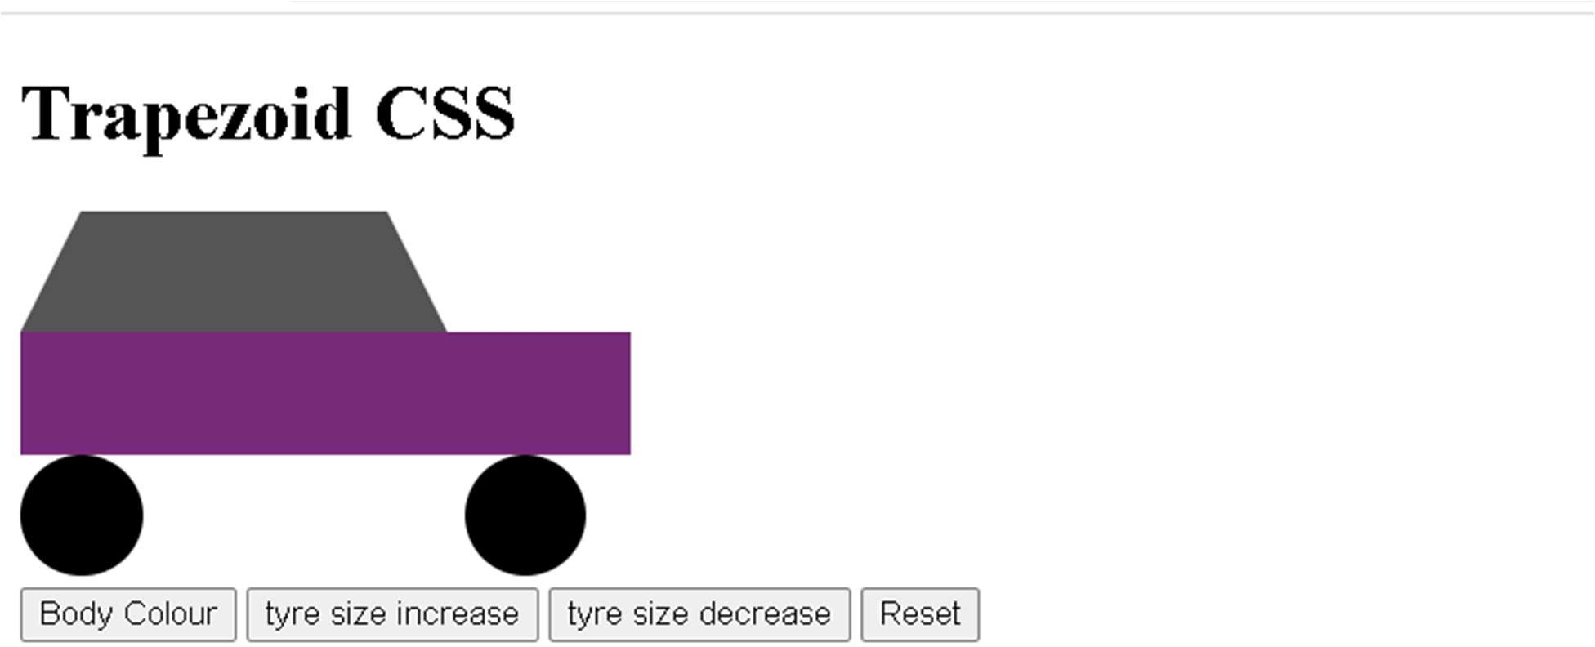

**Result:**

The above program is executed and verified successfully.



Ex. 7 | JQUERY

11